Module 9

Assignment 9.3
Course: CSD402-340A Java for Programmers
Prepared By: Mirach Erkol
Date of Report: 3/1/2025

https://github.com/Mikey5007/CSD340.git

9.3 Assignment:
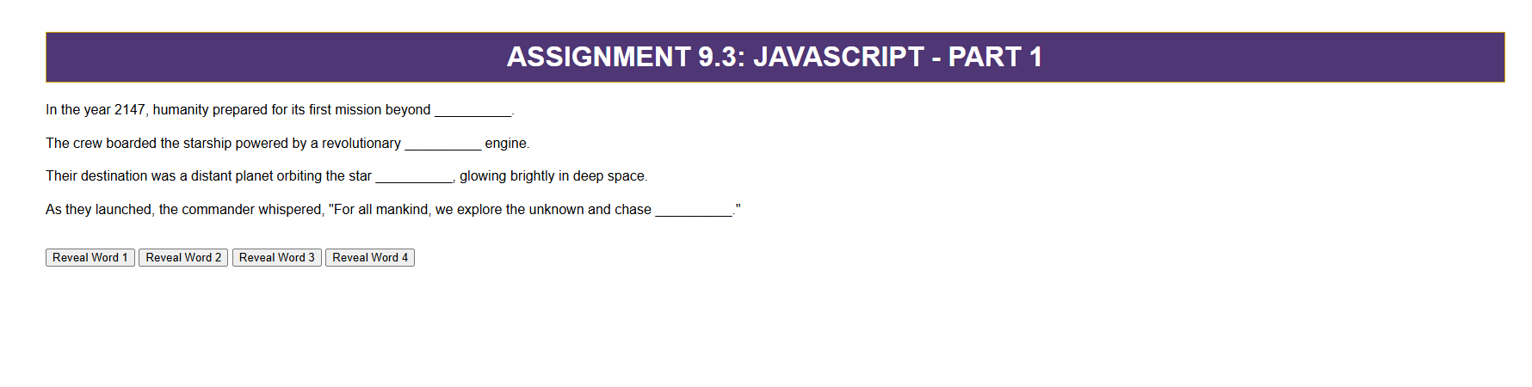

9.3 Assignment:
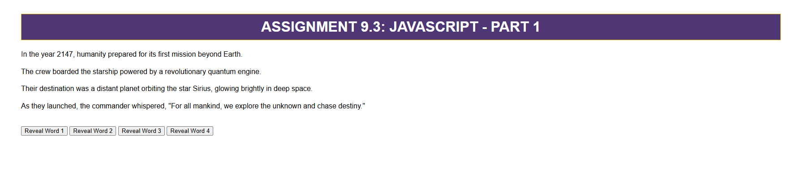

References:

https://github.com/Mikey5007/CSD340.git

